**Patent Draft**

Submitted by:  
Group CS  
Shivam Nautiyal  
Shivam Sharma

Title: **KRISHIKOM**

Field of Invention: APP Development

**Abstract:**

The present invention relates to the field of agriculture technology and, more specifically, to an innovative mobile application called "KRISHIKOM" designed to empower farmers in increasing their income. KRISHIKOM is a user-friendly, React Native-based application that provides a comprehensive set of features to support farmers, including weather monitoring, crop advice, irrigation assistance using augmented reality (AR), sustainable agriculture practices, community building, shared farming equipment, global market trend analysis, financial inclusion through partnerships with financial institutions, and collaboration opportunities with startups. The application aims to bridge the technological gap by offering an easy-to-use interface suitable for individuals with varying levels of literacy. It leverages server technologies such as Node.js and integrates SMS services via Twilio for effective communication. This innovation addresses critical challenges faced by farmers, ultimately leading to improved financial well-being and sustainable agricultural practices.

**Background**

Agriculture plays a pivotal role in global food security and economic development. However, small-scale and marginalized farmers often encounter difficulties in accessing vital information and resources to enhance their agricultural productivity. Addressing these challenges is essential to increase the income and livelihoods of farmers. KRISHIKOM serves as a digital solution to empower farmers with the knowledge and tools necessary for successful farming.

**Objective**

The primary objectives of the KRISHIKOM mobile application are as follows:

1. Weather Monitoring and Crop Advice: Providing real-time weather updates and expert crop advice to help farmers make informed decisions.

2. Sustainable Agriculture Practices: Promoting sustainable farming practices through educational content and guidelines.

3. Community Building and Training: Facilitating the creation of a supportive farming community by connecting farmers and providing training opportunities.

4. Shared Farming Equipment: Enabling farmers to share farming equipment, reducing operational costs.

5. Global Market Trend Analysis: Offering insights into global market trends to aid in crop planning and selling decisions.

6. Farmers - Startups partnership: Promoting partnerships between farmers and agricultural startups for mutual benefit.

9. AR-Based Irrigation Architecture: Implementing augmented reality technology to assist farmers in optimizing irrigation practices.

**Technology Stack**:

- Application: React Native with Expo

- Server: Node.js

- SMS Service: Twilio

**Flowcharts:**

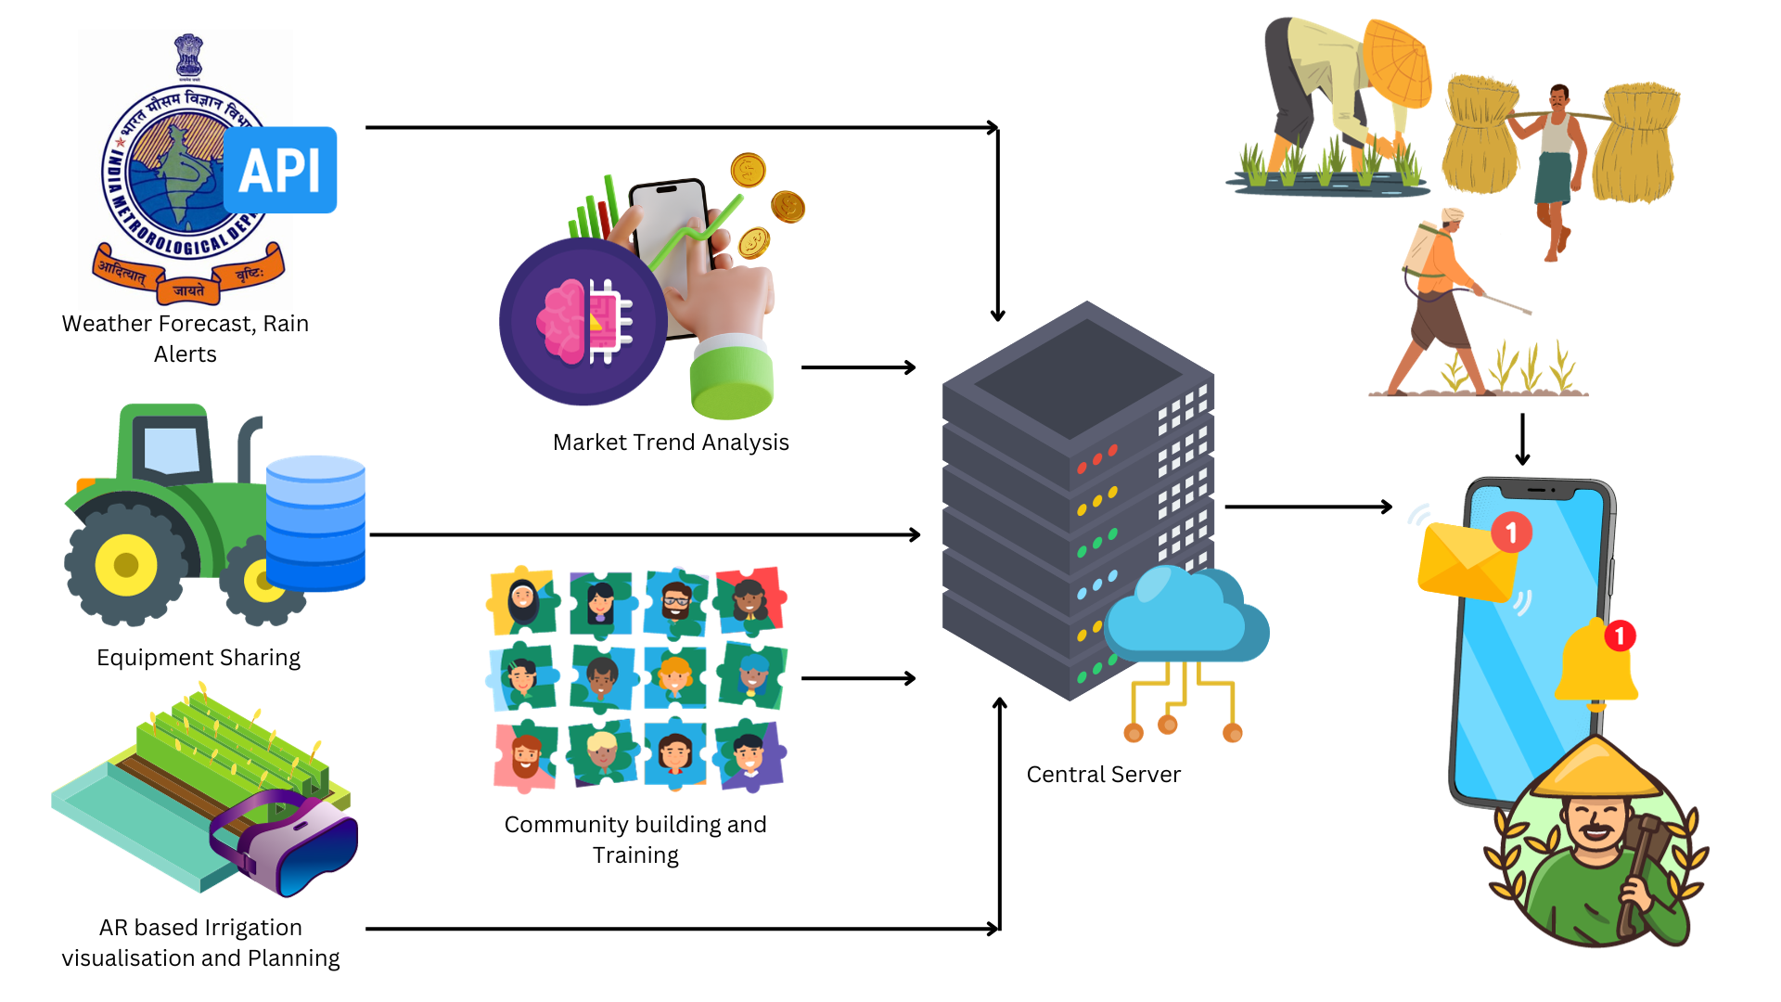

**Claims:**

The proposed project claims to provide the following benefits:

1. Improved income and livelihoods for farmers.

2. Enhanced agricultural productivity through weather monitoring and expert advice.

3. Innovative use of augmented reality for efficient irrigation.

4. Promotion of sustainable farming practices.

5. Establishment of a supportive farming community.

6. Cost-effective shared farming equipment solutions.

7. Access to global market trends.

8. Financial inclusion through partnerships with financial institutions.

9. Collaboration opportunities between farmers and startups.

**End Users:**

The end users of the KRISHIKOM mobile application include:

- Small-scale and marginalized farmers seeking to improve their agricultural practices and income.

-Companies like Jiomart so that they buy stuff from farmers

-Government for managing the data of farmers

**Advantages:**

- User-friendly interface suitable for individuals with varying levels of literacy.

- Integration of real-time weather updates and crop advice.

- Augmented reality-based irrigation guidance.

- Promotion of sustainable farming practices.

- Facilitation of community building and training.

- Efficient sharing of farming equipment.

- Access to global market trends.

- Financial inclusion through partnerships.

- Collaboration opportunities with startups.

**Summary/Conclusion:**

KRISHIKOM is a groundbreaking mobile application designed to uplift farmers in the agriculture industry. With its easy-to-use interface, innovative features, and robust technology stack, KRISHIKOM addresses the challenges faced by farmers and contributes to improved agricultural productivity, financial well-being, and sustainable practices. This digital solution is poised to transform the way farmers engage with technology, fostering a brighter future for agriculture.